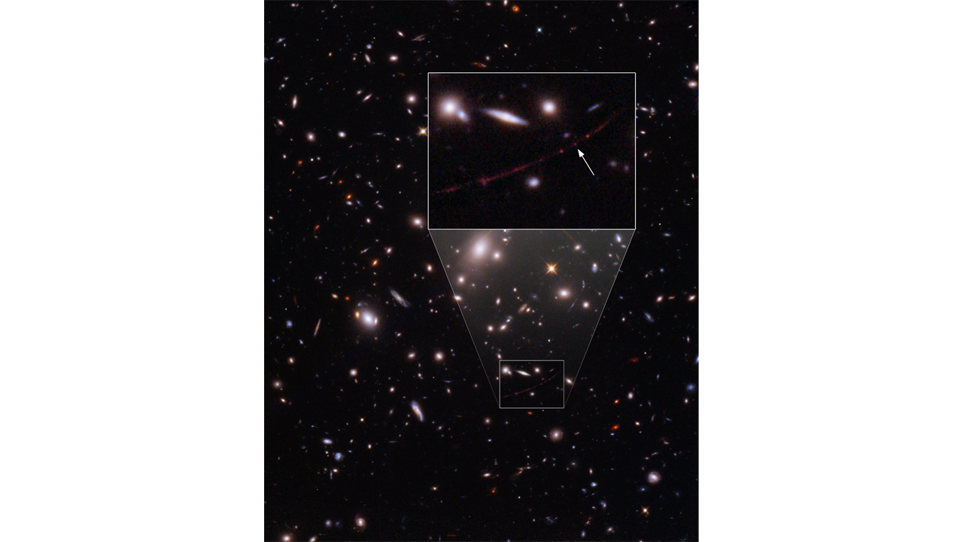

From the Beginning

Alan Millner July 2022

Earendel,

That star from the dawn of the universe

Seen by the Hubble telescope

The farthest, oldest single star ever imaged

28 billion light years away from here

12.9 billion years its light traveled to us

While the star moved away as space expanded

That photon crossed the universe

And landed on the telescope sensor array

Splat like a bug on the windshield.

One of an early generation of suns

That star is gone now

Only its light remains

And its elements scattered in the birth of other stars

Even its light visible only because

The galaxies between us bent the spaces

And focused its reddened arc here.

Now look at it from the photon’s point of view

Relativity tells us

When something travels close to the speed of light

Its time slows down, it ages less

And if it travels at the speed of light

Which, of course, it does

Time stops for it.

So from the time that photon

Fled the star

To when it was seen by Hubble

No time has passed for it,

In its reference frame

The universe went flying past it

All scrunched up along its length

By the Lorenz-Fitzgerald contraction

To no distance at all

One instant emitted by Earendel

The next instant captured by Hubble

Time passes quickly

When you’re having fun

Splat.